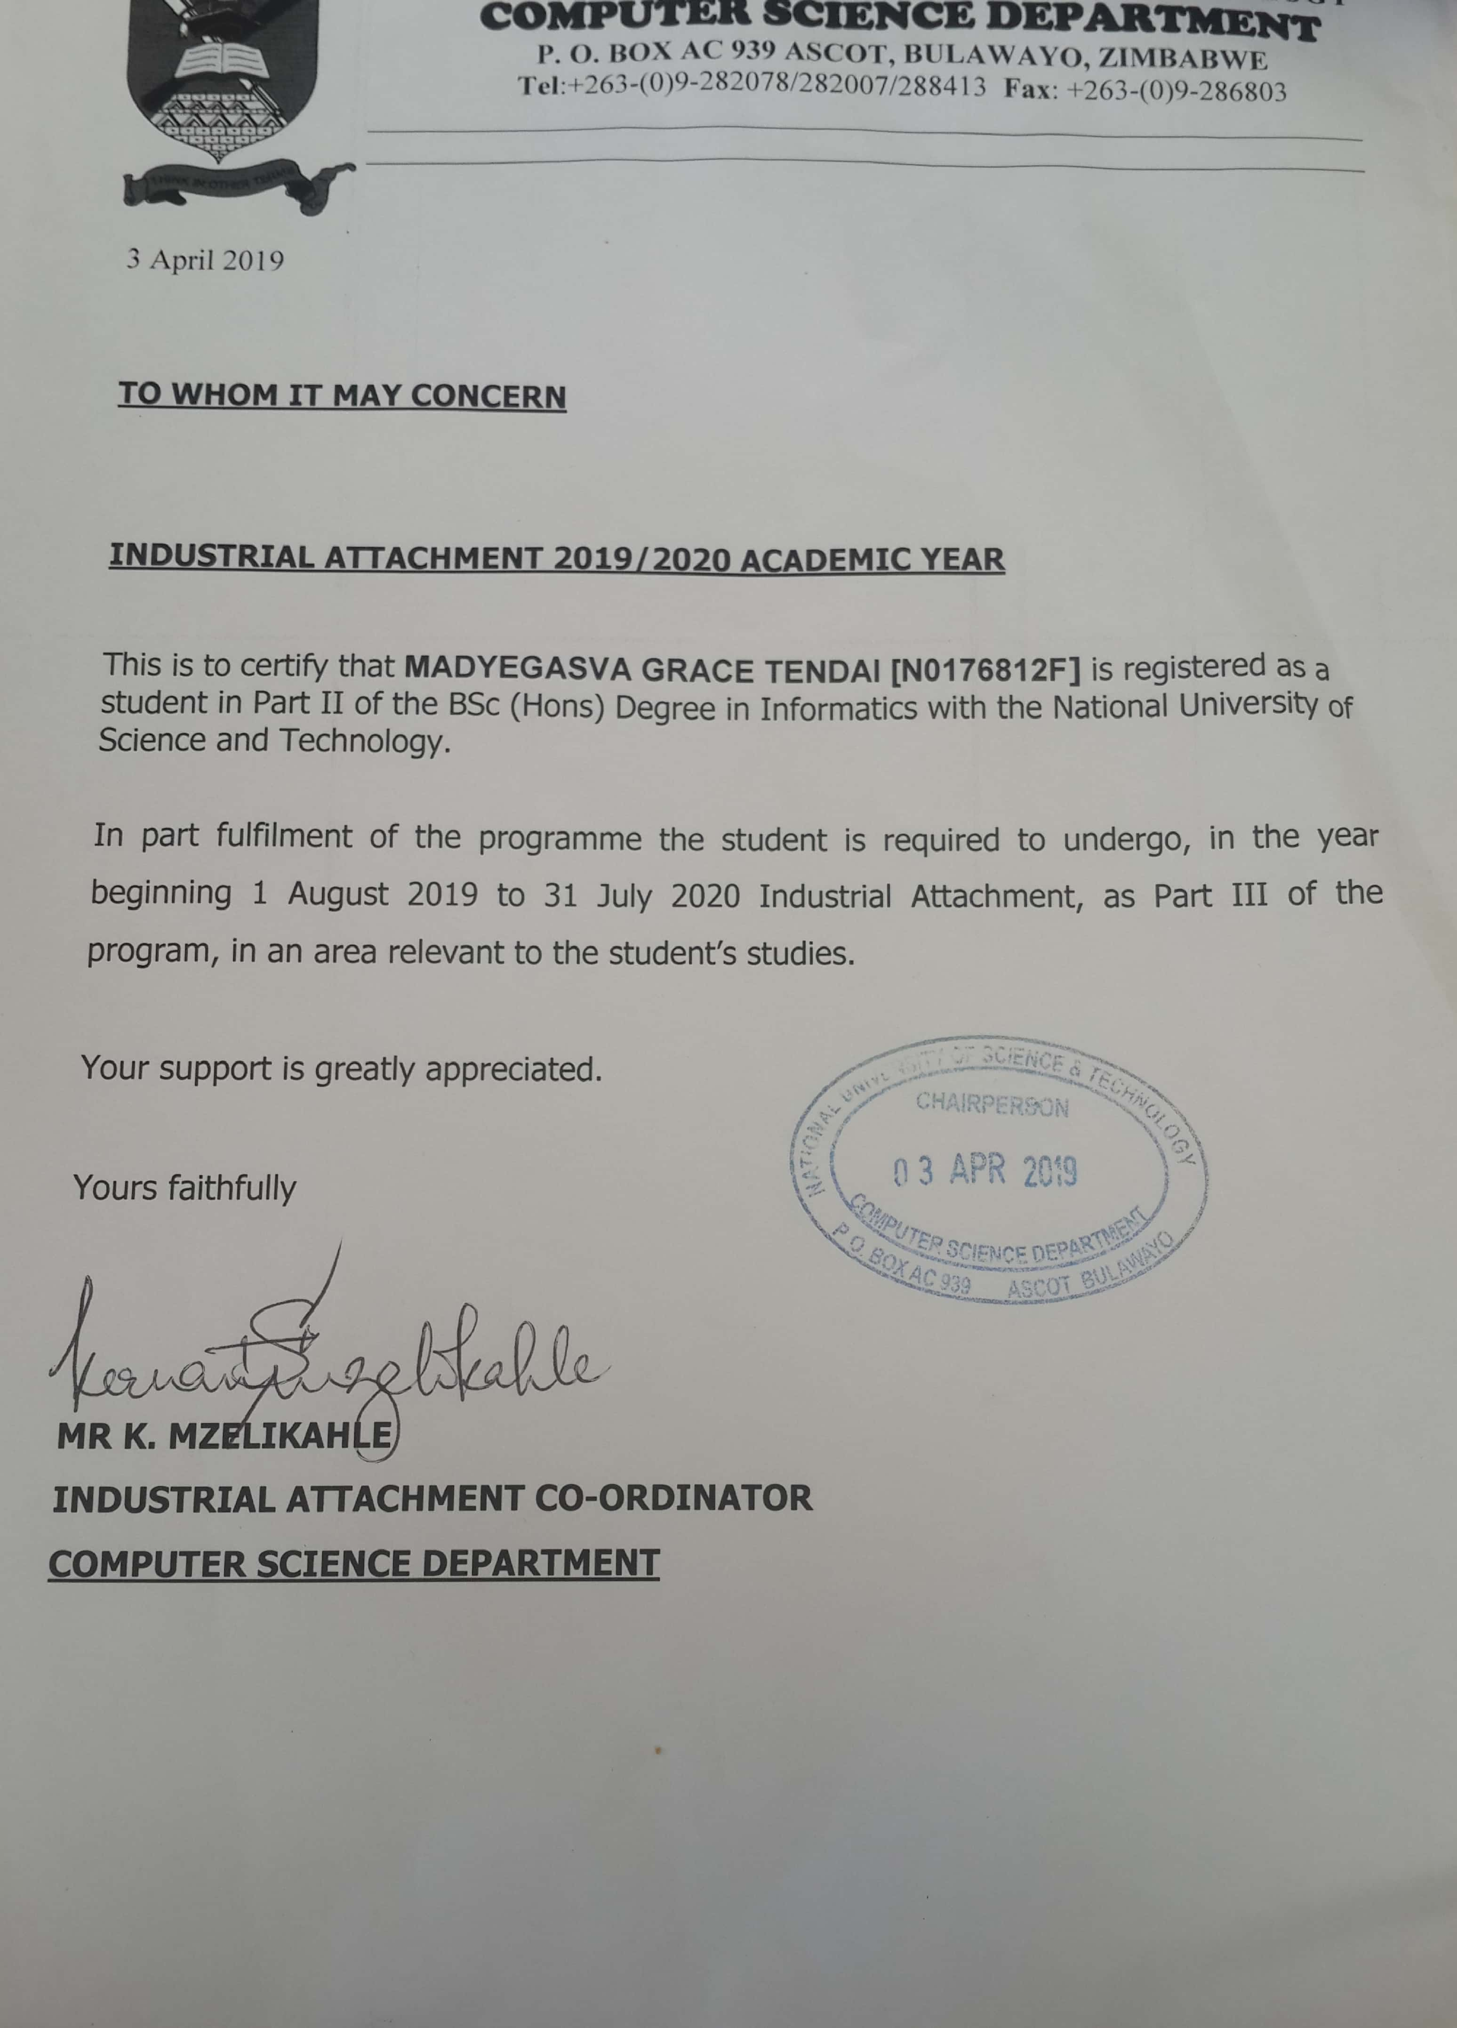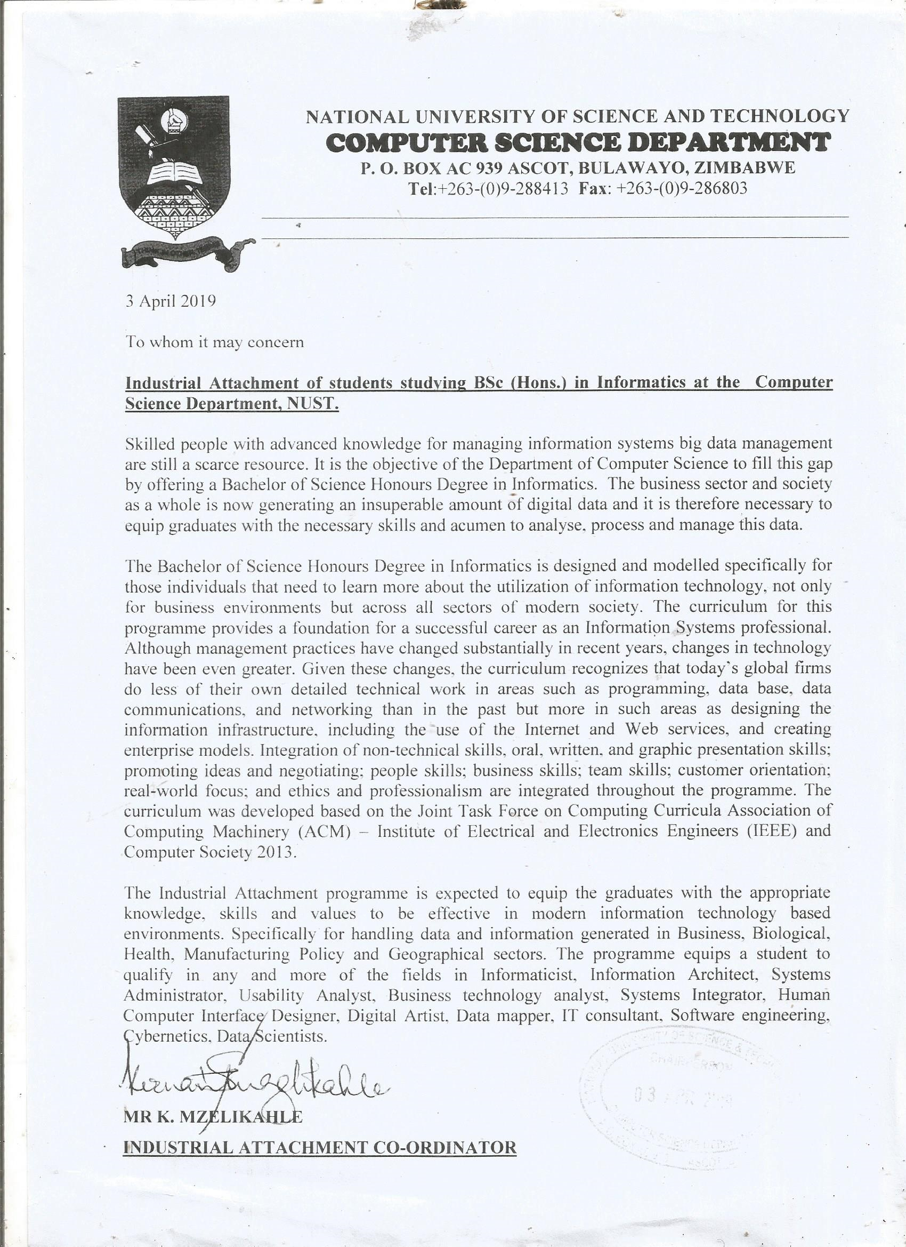

CURRICULUM VITAE FOR GRACE TENDAI MADYEGASVA
Contact Address: 19 Lyndon Moore Road, Southerton, Harare, Zimbabwe
E-mail: gracemadyegasva@gmail.com
Cell: +263 776619513 / +263 719339222
…………………………………………………………………………………………………..................
PERSONAL DETAILS
Family Name Madyegasva
First Name Grace Tendai
Date of birth 04 June 1996
Nationality Zimbabwean
Citizenship Zimbabwean
Gender Female
Marital Status Single
Religion Christianity
Languages English, Shona and Ndebele
……………………………………………………………………………………………………………..
I consider myself loyal, reliable, hardworking, task-driven, a problem solver, able to plan, organize, work as part of a team and can work well under pressure. I have good communication skills and enthusiastic to learn and enrich my knowledge in the field of informatics by undertaking a thorough hands-on industrial attachment at a reputable organization.
……………………………………………………………………………………………………………..
ACADEMIC QUALIFICATIONS
Aug 2017 – July 2021 National University of Science and Technology, Zimbabwe
Programme Bachelor of Science Honours Degree in Informatics (Full-time)

2013 – 2014 GCE Advanced Level – Harare First Choice College, Harare
Subjects studied & passed Mathematics, Management of Business and Accounting

2009 – 2012 GCE Ordinary Level – Masotsha High School
7 Ordinary Level subjects passed including English Language and Mathematics
……………………………………………………………………………………………………………..
National University of Science and Technology Results
Part | Course | Result
1.1  (Aug 2017-Dec 2017) | Communication Skills | 2.2
1.1  (Aug 2017-Dec 2017) | Information Management Concepts | 2.2
1.1  (Aug 2017-Dec 2017) | Electronic Commerce | 2.1
1.1  (Aug 2017-Dec 2017) | Introduction to Computer Science and Programming | 2.1
1.1  (Aug 2017-Dec 2017) | Mathematical Foundation of Computer Science | 1
1.2  (Feb 2018-June 2018) | Conflict Transformation and Leadership | 1
1.2  (Feb 2018-June 2018) | Business Information Systems and Applications | 2.2
1.2  (Feb 2018-June 2018) | Data Mining and Warehouse | 1
1.2  (Feb 2018-June 2018) | Data Visualisation and Reporting | 1
1.2  (Feb 2018-June 2018) | Visual Programming Concepts and Development | 2.1
1.2  (Feb 2018-June 2018) | Applied Statistics | 2.1
Overall Part 1 Class |  | 2.1
2.1  (Aug 2018-Dec 2018) | Project Management | 1
2.1  (Aug 2018-Dec 2018) | Research Methods | 1
2.1  (Aug 2018-Dec 2018) | Human Computer Interaction | 1
2.1  (Aug 2018-Dec 2018) | Data Analysis and Simulation | 2.1
2.1  (Aug 2018-Dec 2018) | Application Development | 2.1
2.1  (Aug 2018-Dec 2018) | Computer Data Communications | 2.1
2.2  (Feb 2019-June 2019) | Decision Support Systems | Pending
2.2  (Feb 2019-June 2019) | Parallel and Distribution Processing | Pending
2.2  (Feb 2019-June 2019) | Expert Systems | Pending
2.2  (Feb 2019-June 2019) | Information Security and Auditing | Pending
2.2  (Feb 2019-June 2019) | Internet and Web Designing | Pending
2.2  (Feb 2019-June 2019) | Introduction to Molecular Genetics | Pending
Overall Part 1 Class |  | Pending
......................................................................................................................................................................
COMPUTER SKILLS AND LITERACY
R programming, Python, Hadoop, Visual Basics, C#, Java Programming, Data scientist and analysis, Database management, Data mining and Microsoft Office

Extra – curricular roles at High School
- Netball and soccer
- Indoor games
……………………………………………………………………………………………………………..
HOBBIES
Voluntary community work, watching TV and cooking.
……………………………………………………………………………………………………………..
REFEREES

Mr. K Mzelikahle
Lecturer and Industrial Attachment Coordinator
Department of Computer Science, National University of Science & Technology
P. O Box AC 939 Ascot, Bulawayo
Tel +263 9 282842 Extension 2499, Cell +263…
E-mail k.mzelikahle@gmail.com / also add the nust email

(Put initial as in Prof, or Dr or Mr.) Thambo Nyathi
Chairperson
Department of Computer Science, National University of Science & Technology
P. O Box AC 939 Ascot, Bulawayo
Tel +263 9 282842 Extension 2332/2452, Cell +263…
E-mail compscie@nust.ac.zw / also add the nust email

……………………………………………………………………………………………………………..

